NEWS RELEASE
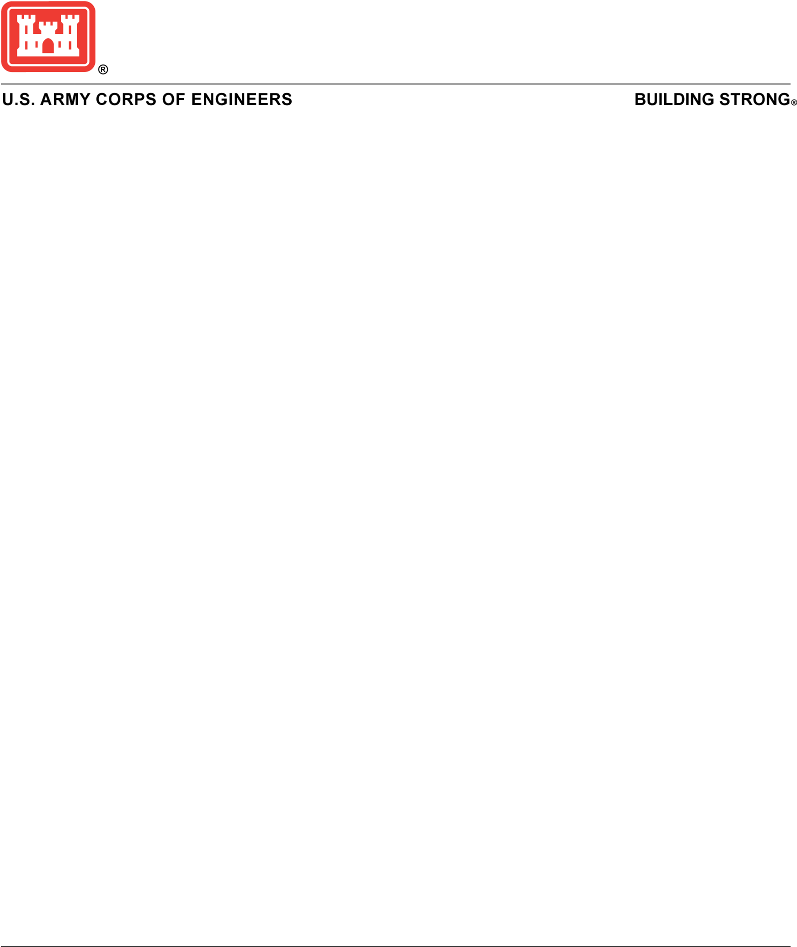
Media Contact:
Randy Cephus or Breeana Moore
(409) 766-3005
swgpao@usace.army.mil
Release No. 170823

For Immediate Release:
August 23, 2017

The Galveston District prepares for Tropical Storm Harvey

GALVESTON, Texas (August 23, 2017) – The Galveston District initiated emergency operations on Tuesday afternoon in preparation for Tropical Storm Harvey at its District office in Galveston.

The district’s crisis action team is fully manned and monitoring the current situation. The team is in constant communication with its area offices, weather forecasters, emergency management officials, first responders and project partners. Vessels used in support of current dredging and other construction projects are either currently anchored, or have a plan for anchorage if the situation worsens.
Also included in the emergency preparations are the distribution of gabion bastions, super sandbags and other flood fighting equipment to coastal project areas from Brownsville to Port Arthur.
A gabion bastion is a collapsible wire mesh container and heavy duty fabric liner used as a temporary to semi-permanent measure to defend against storm surge. Similar bastions were successfully used in 2005 to reinforce levees around New Orleans during emergency operations between Hurricanes Katrina and Rita.
The Addicks and Barker Dams, which provide flood risk reduction to the Houston area, are in good condition and the construction on the outlet structures continues. The dams are operational and ready to receive rainfall.

Although, preparations are being made all along the Texas coast, a critical area of concern is the floodwall which Jefferson County’s Drainage District #7, the local sponsor, is currently repairing near Taylor’s Bayou in Port Arthur, Texas. These items will be used to shore up vulnerable areas and assist in flood fighting efforts.
According to Corps officials, approximately 850 feet of GABION will be added behind the pilings and the railroad tracks located behind them. The GABION will be placed on a 7-foot high concrete sand stabilization platform that was put in place Aug. 21. An additional 1400 feet of GABION will be shipped from the Corps’ Fort Worth office today. Once the GABIONs are in place, super sand bags will be used to connect the GABION to the pilings over the railroad tracks.
The Port Arthur Hurricane Flood Protection Project (PAHFPP) is a federally constructed, locally maintained system active in the PL84-Rehabilitation and Inspection Program (RIP).
The system consists of 34.4 miles of protected works which includes 27.8 miles of earthen levee, 6.6 miles of concrete and steel sheet pile floodwalls, drainage and closure structures, pump stations and a wave barrier. The system protects Port Arthur and vicinity to include cities of Groves, Lakeview, Pear Ride, Port Acres, Griffin Park, Port Neches and unincorporated areas of Jefferson County.
On Aug. 1, Drainage District #7 identified a 600-foot compromised section of the system's floodwall, including 200 feet of failure, requiring repairs to return the system to its identified level of protection. Placement of 1700 Super sandbags on top of the filled scour hole began on Aug. 17.

###USACE###

