
MEDIA ADVISORY
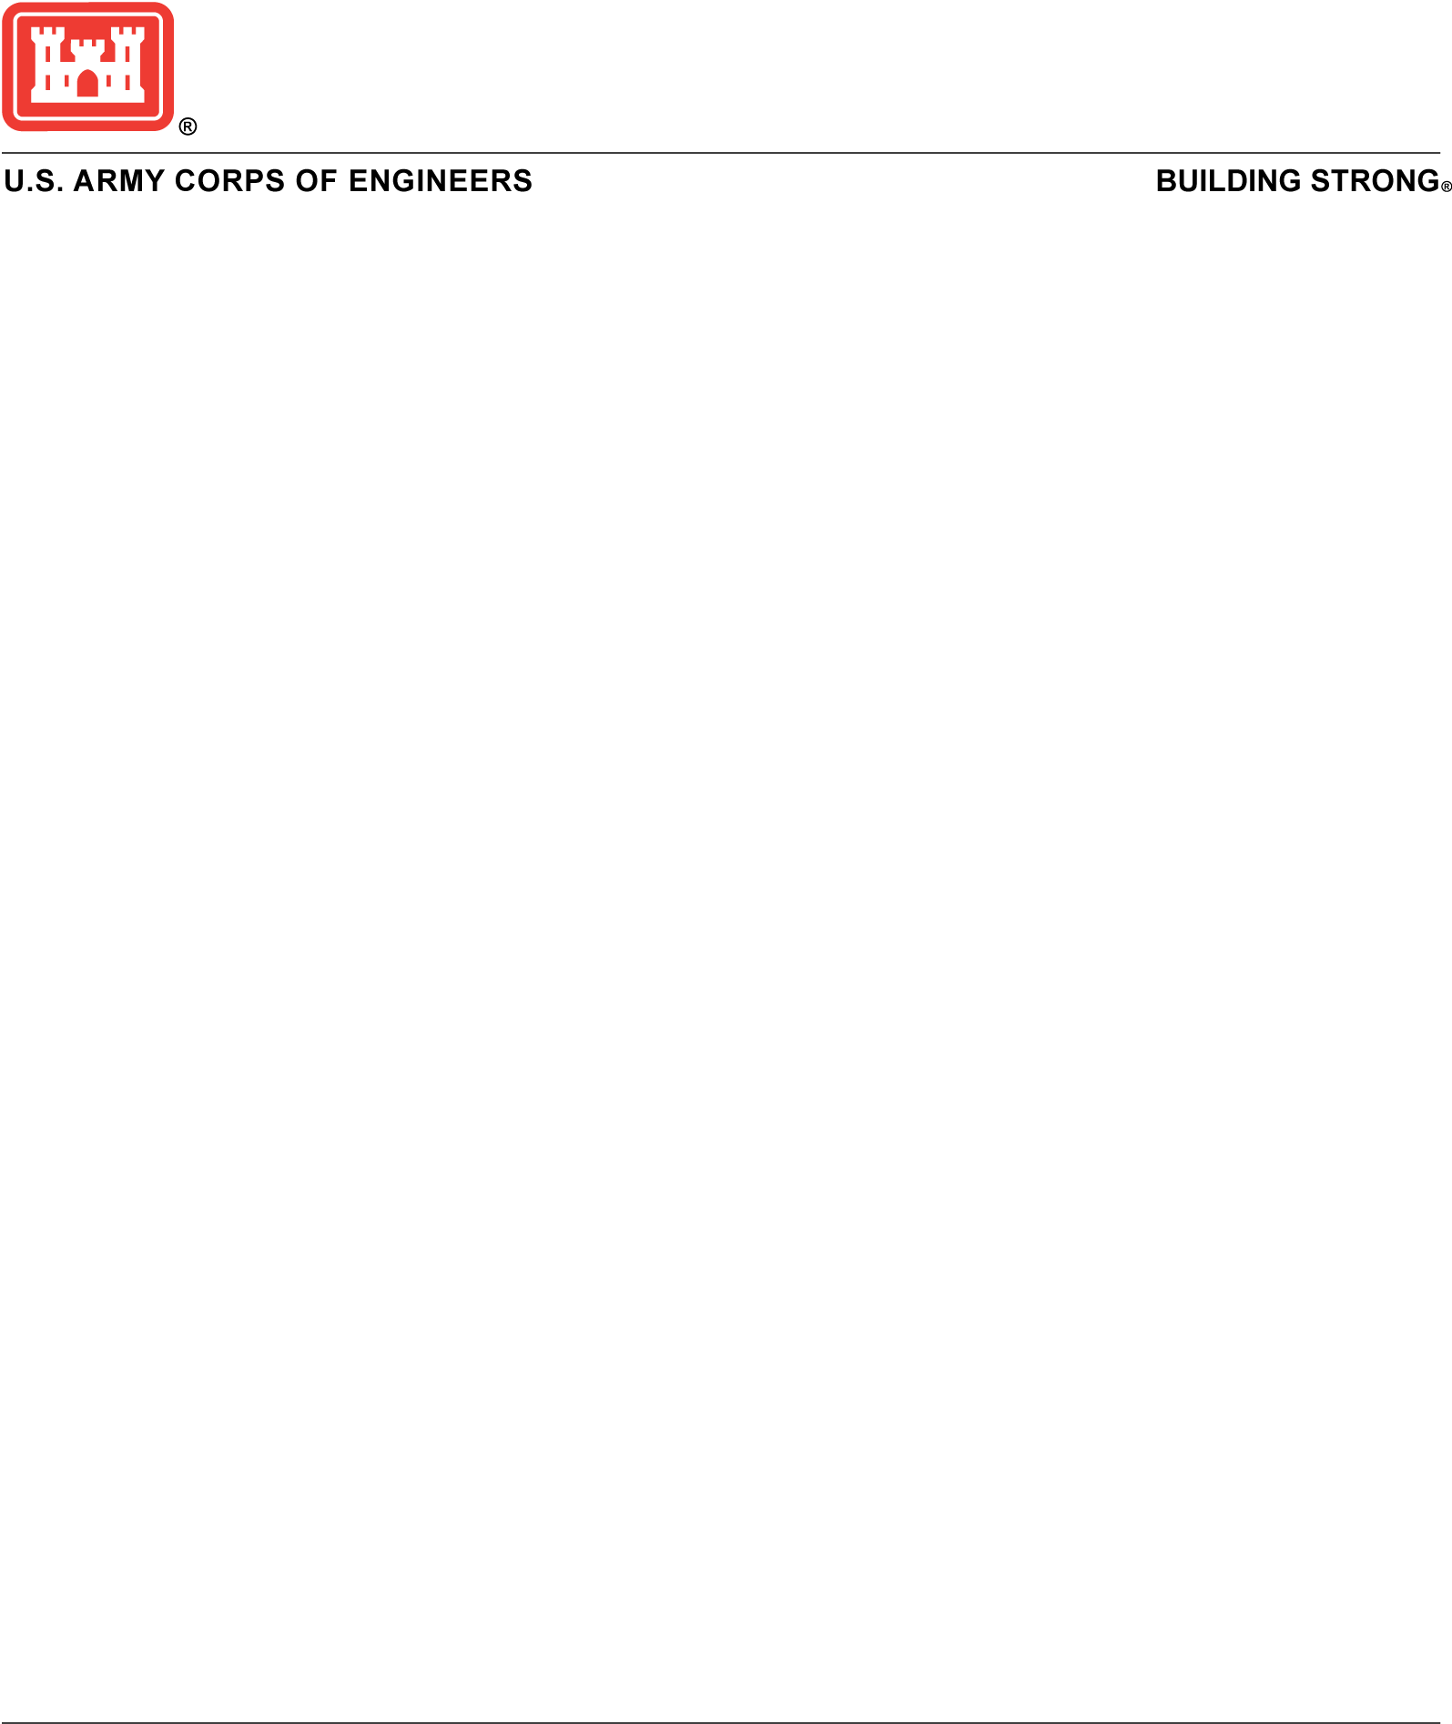
Media Contact:
Jefferson County Drainage District 7, at 409-985-4369
USACE Public Affairs, at swgpao@usace.army.mil
Release No. 170802

For Immediate Release:
August 08, 2017

Media Opportunity at Taylor Bayou Floodwall

GALVESTON, Texas (August 4, 2017) – Jefferson County Drainage District No. 7 and the Galveston District, US Army Corps of Engineers will host a media availability to provide an update on the status of the compromised floodwall near Taylor Bayou in Port Arthur, Texas.

WHAT: Joint statement from DD7 and the Corps followed by a questions and answers session. A visual tour of the floodwall will follow. Active construction site attire such as closed toed shoes, pants and long sleeve shirts are highly suggested.

WHEN: Wednesday, August 9, from 10:00 am to 11:00 am

WHERE: Taylor Bayou

Interested media should contact the DD7 at 409-985-4369 NLT 4:00 p.m. Tuesday, August 8.

